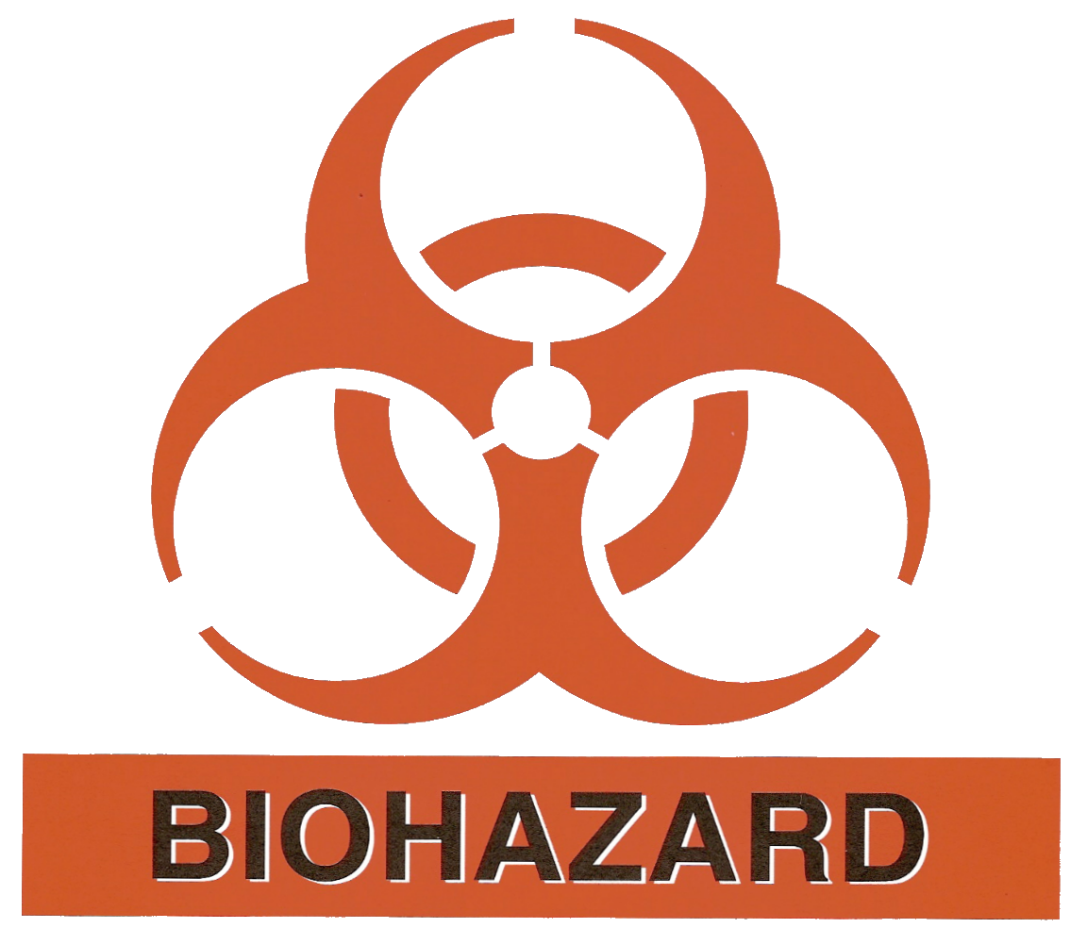
Animal Standard Operating Procedure
Adenoviral vectors
Animal Safety Protocol designation | - ABSL-2  - Agent may be excreted by the animals 72 hours post injection therefore precautions must be taken to avoid the creation of aerosols when changing or washing cages, or cleaning the room  - See investigator responsibilities below
Investigator Responsibility | - Research staff must inform Animal Care staff ahead of time that the agent will be used, and arrangements will be made for housing of animals.  - Fresh micro-isolator caging will be used for the animals at the time of administration.  - Biohazard Sign must be posted on the door of the room in which the animals will be housed while experiments are in progress.  - Cages will be labeled with a pink card with the following information:  - Name of agent delivered to animal  - Approximate dose  - Date of administration  - Date of bedding change  - Cards and door signs must be removed by the researcher once the hazard is no longer present.
Entry requirements | - All Personal Protective Equipment (PPE) gown, gloves, face mask, goggles, shoe covers and cap must be worn to enter animal room.  - Hands must be washed upon exiting animal room.  - Surgical masks, goggles, faceshields or use of a Biological Safety Cabinet (BSC) are required when conducting research.
Cage Change | - Animal waste and contaminated bedding shall be handled to minimize generation of dust and aerosols.  - Items potentially contaminated with the agent will be sprayed with 10% bleach and bagged using red biohazard bags prior to removal from the animal room.  - Contaminated bedding must be emptied from cages using a dump station or Class II biosafety cabinet.
Decontamination and Spill Procedure | - Empty cages will be sanitized by standard IAS practices  - If a spill occurs, all traffic to the area will be immediately restricted and 10% freshly prepared bleach or appropriate disinfectant will be used for clean up. Care will be taken to minimize aerosols during the clean-up process.  - Equipment and work surfaces must be routinely cleaned with 10% freshly prepared bleach or appropriate disinfectant. All equipment must be decontaminated prior to removal from the room housing the infected animals.

